Chapter 4, Problem 49.

Find the Norton equivalent looking into terminals a-b of the circuit in Fig. 4.102.

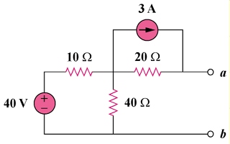

Figure 4.102
For Prob. 4.49.

